DDL COMMANDS(CREATE, ALTER, DROP, TRUNCATE)
1.CREATE:
DATABASE AND TABLE CREATION
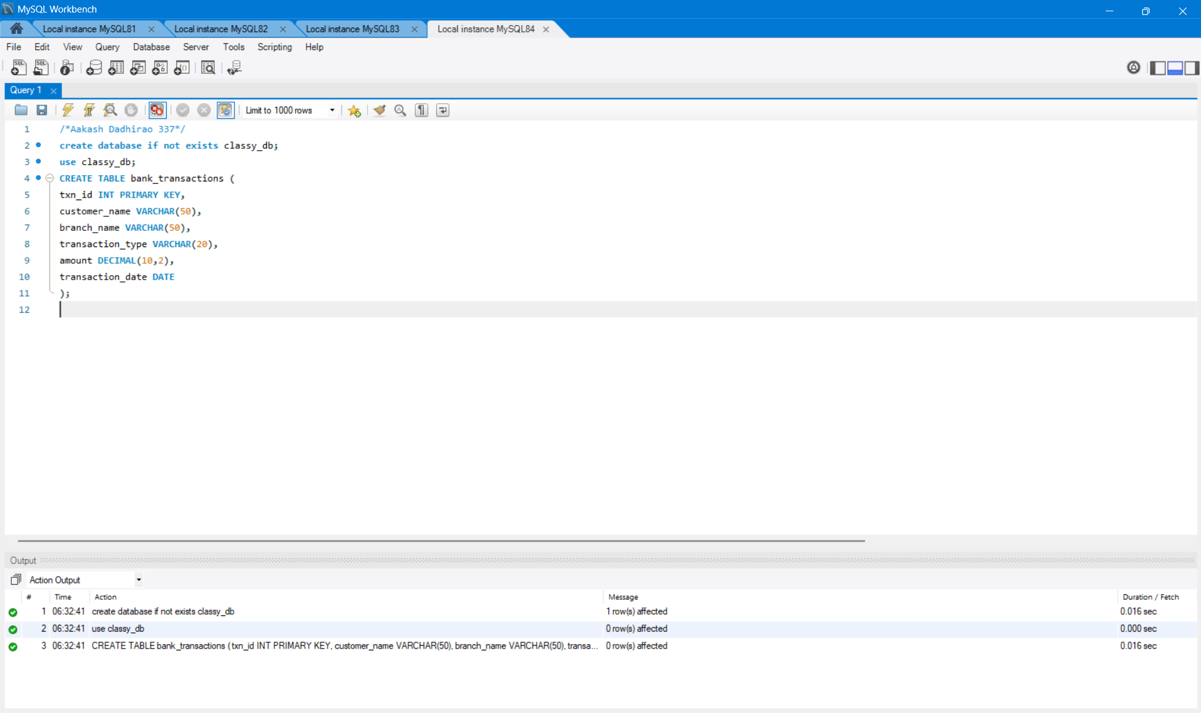

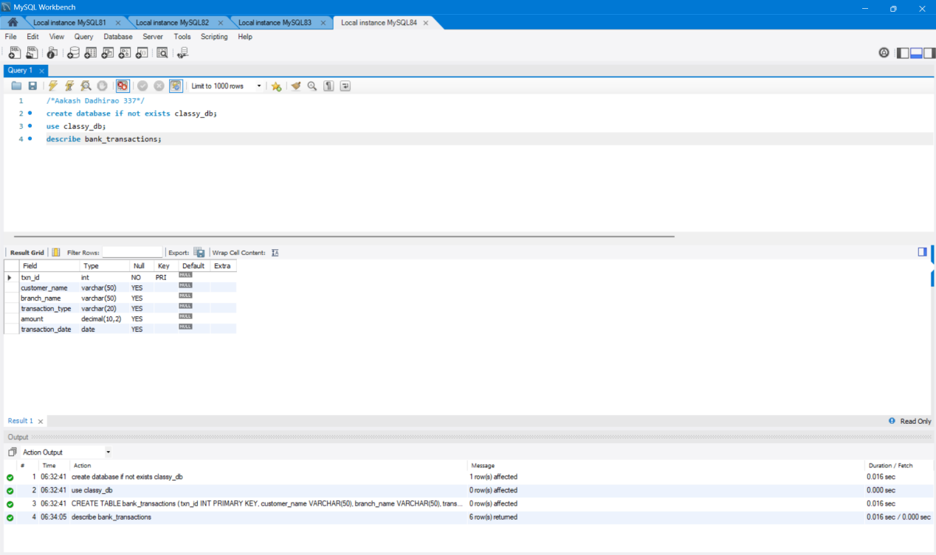

2.ALTER:
2.1.MODIFY:
BEFORE:VARCHAR(50)

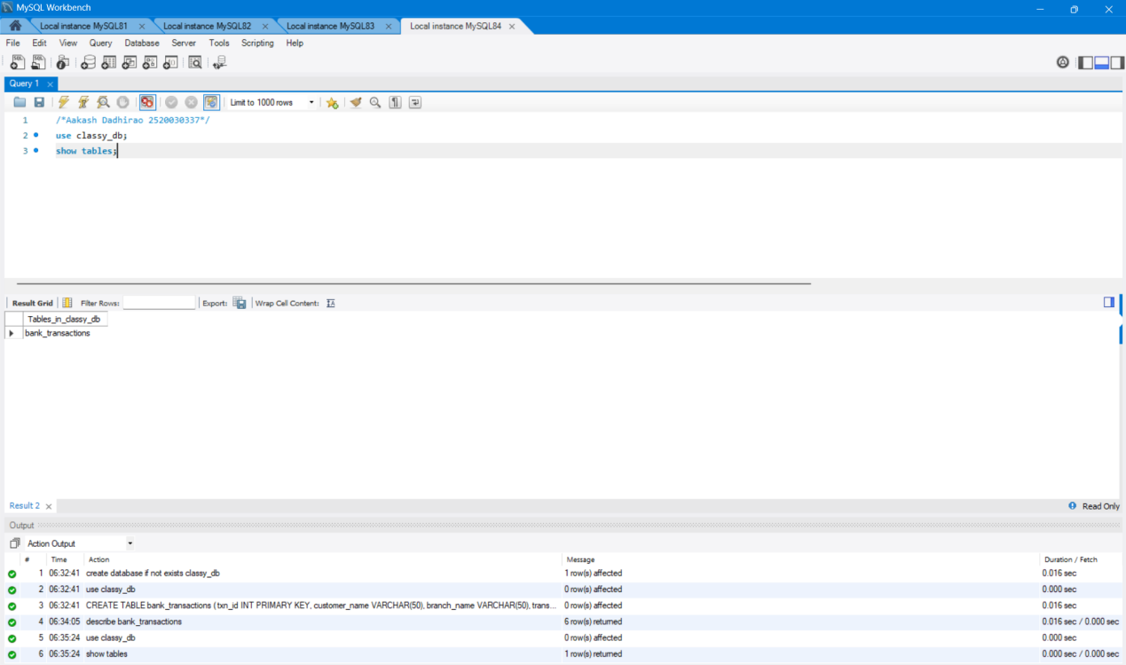
AFTER:VARCHAR(100)
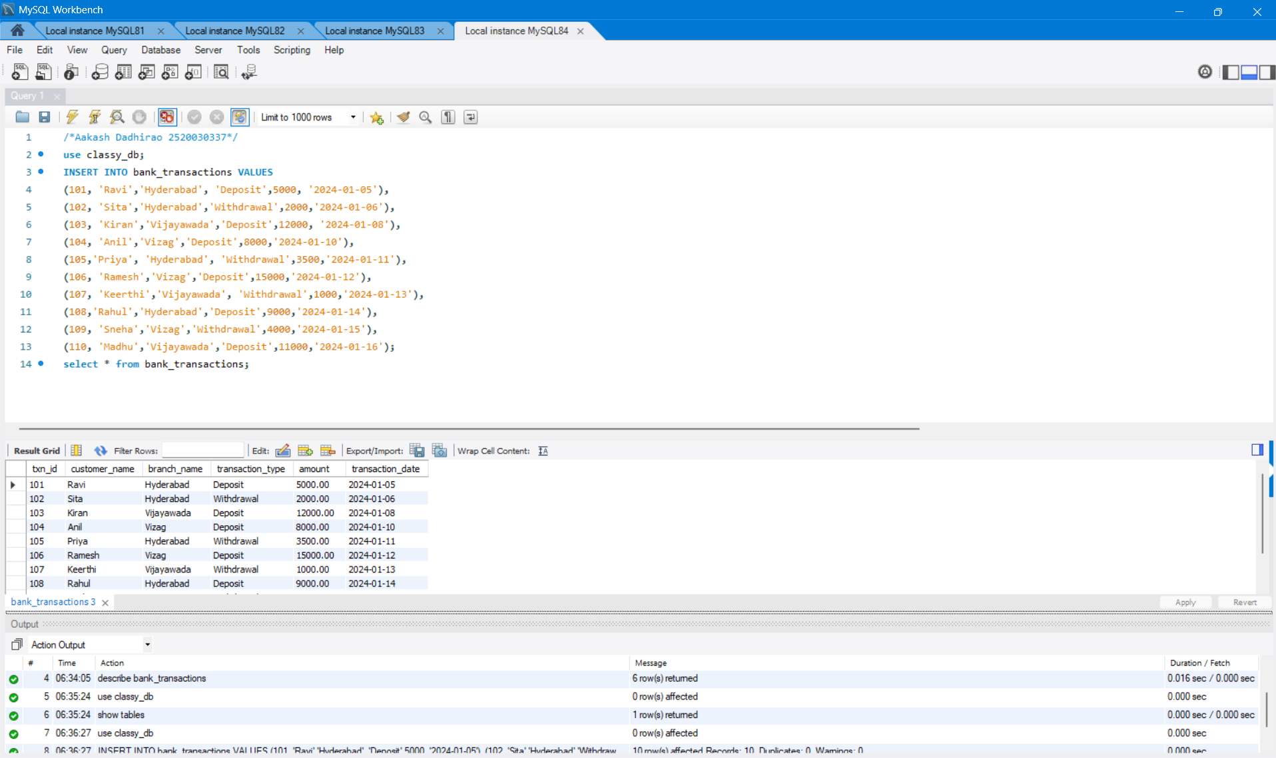

2.2.RENAME
BANK_TRANSACTIONS TO CUSTOMER_TRANSACTIONS
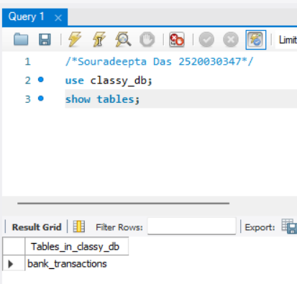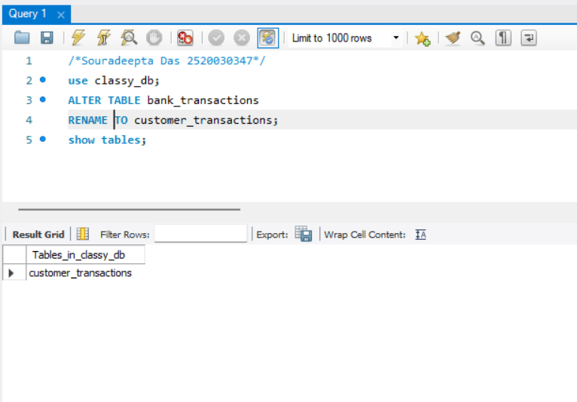

INSERT VALUES:


3.TRUNCATE
BEFORE TRUNCATE:

AFTER TRUNCATE:

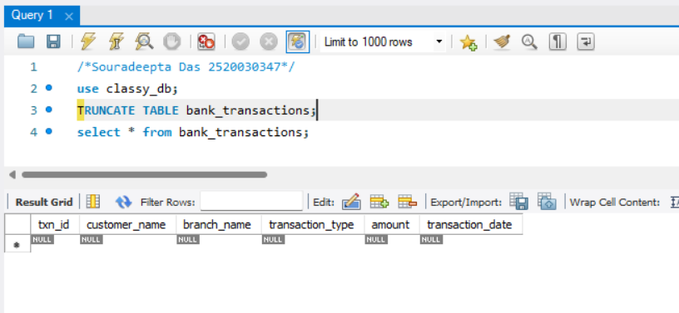



4.DROP
BEFORE DROPPING BANK_BACKUP
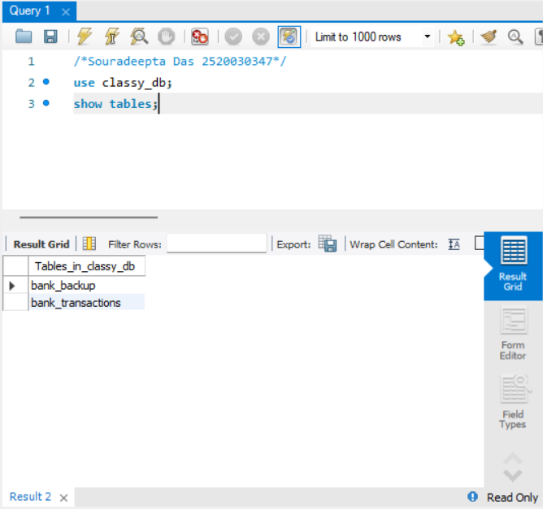

AFTER DROPPING BANK_BACKUP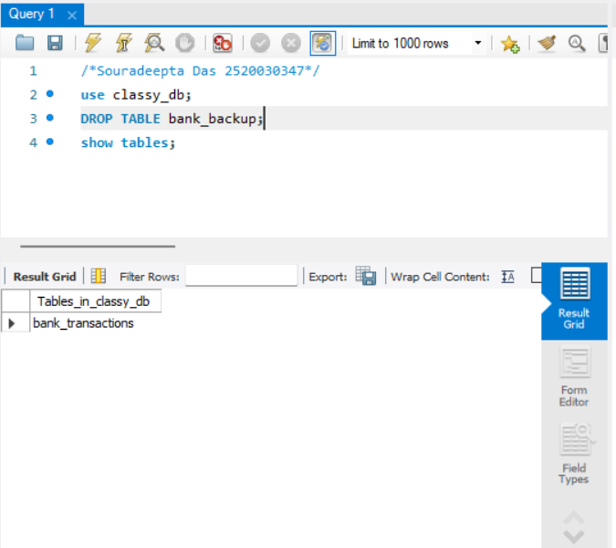

INSERT
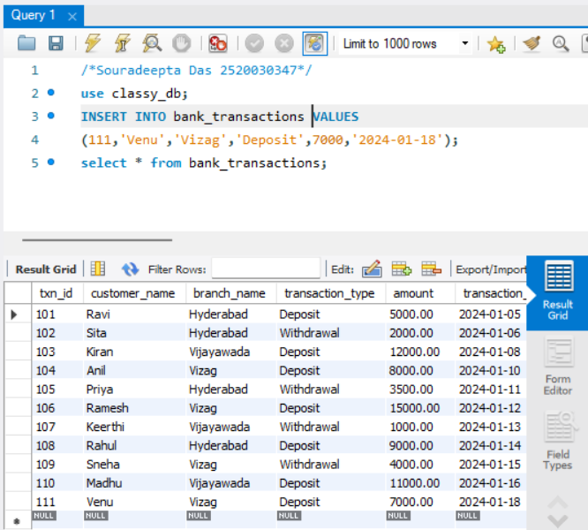
UPDATE
BEFORE UPDATE
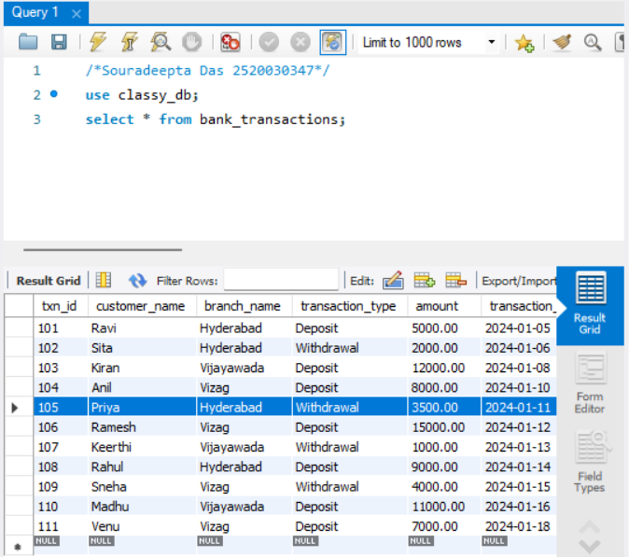

AFTER UPDATE

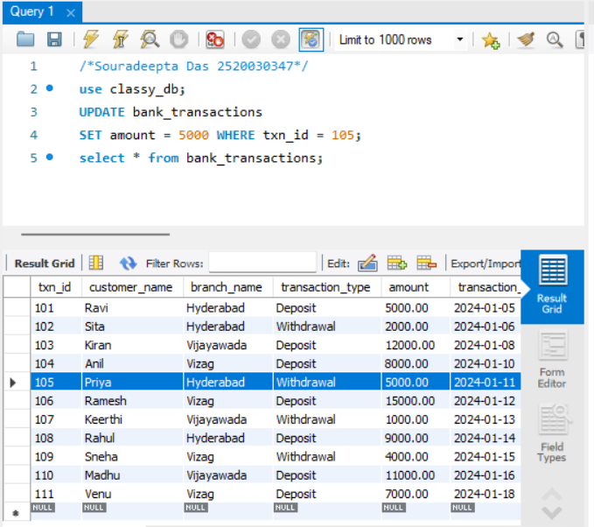
DELETE
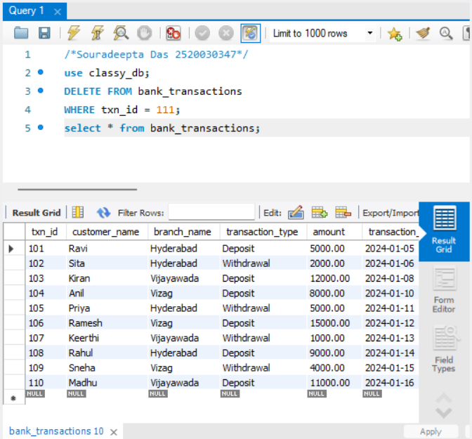

ORDER BY

